**Project Design Phase-II**

**Technology Stack (Architecture & Stack)**

|  |  |
| --- | --- |
| **Date** | 20 October 2022 |
| **Team ID** | PNT2022TMID32703 |
| **Project Name** | Project - Visualizing and Predicting Heart Diseases with an interactive Dashboard |
| **Maximum Marks** | 4 Marks |

**Technical Architecture:**

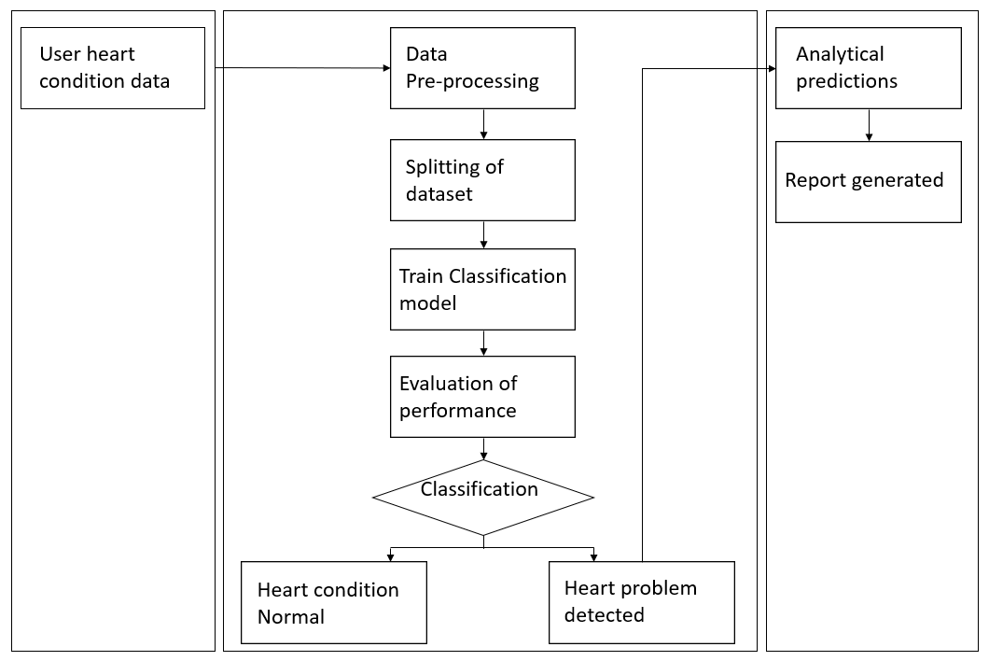

**Table-1 : Components & Technologies:**

|  |  |  |  |
| --- | --- | --- | --- |
| **S.No** | **Component** | **Description** | **Technology** |
|  | User Interface | User interacts with application through web user interface | HTML, CSS, JavaScript |
|  | Importing data | Data is imported from external sources and is used for analysis | Python, Numpy |
|  | Data Pre-processing | Data Pre- processing is the process of transforming raw data into useful, understandable format. It includes Data Cleaning, Data Transformation and Data Reduction | Python, Pandas, Numpy |
|  | Splitting the dataset | We split the dataset into train and test sets to evaluate how well our machine learning model performs | IBM Watson Assistant |
|  | Training data | Training data is the subset of original data that is used to train the machine learning model. | Python |
|  | Building model | Building a machine learning model to predict heart disease with the given data | Python |
|  | Model training | Train the model using the Train and Test data. | Python |
|  | Evaluation of performance | The model is evaluated against several evaluation metrics like accuracy to find out its strengths and weakness | IPython |
|  | Infrastructure (Server / Cloud) | Application Deployment on Local System / Cloud  Local Server Configuration:  Cloud Server Configuration : | Local, Cloud Foundry, Kubernetes, etc. |

**Table-2: Application Characteristics:**

|  |  |  |  |
| --- | --- | --- | --- |
| **S.No** | **Characteristics** | **Description** | **Technology** |
|  | Open-Source Frameworks | Frameworks are about more than just creating a development environment. They help to define a set of standards that programmers can follow when working collectively. When programmers choose a certain framework, they adopt the specific tools and methodologies associated with that framework. This also means they must be mindful of your choice, as they may end up with processes that do not fit the needs of their project or the developers involved. | Metadata modeling tool |
|  | Security Implementations | IAM Controls and Encryptions are implemented to improve security of the application. | IBM Cognos software security |
|  | Scalable Architecture | Scalable operations are implemented using APIs like HTTP, HTTPS. | Planning Services, API Gateway |
|  | Availability | To ensure high availability and optimal service, the load balancer performs continual health checks of each server in the cluster, using probes to determine its eligibility for requests. | Server Load Balancers |
|  | Performance | Performance of the system is increased using caching methodology | Caching |

**References:**

[**https://towardsdatascience.com/data-pre-processing-techniques-you-should-know-8954662716d6**](https://towardsdatascience.com/data-pre-processing-techniques-you-should-know-8954662716d6)

[**https://www.geeksforgeeks.org/data-preprocessing-in-data-mining/**](https://www.geeksforgeeks.org/data-preprocessing-in-data-mining/)

[**https://realpython.com/train-test-split-python-data/**](https://realpython.com/train-test-split-python-data/)